**CTS DIGITAL NURTURE - 4.0 JAVA FSE**

**WEEK 8 - GIT**

**3.Git HOL3**

* **Construct a branch, do some changes in the branch, and merge it with master (or trunk)**

**STEPS:**

1. **Create a new branch:**



1. **Switch to the new branch:**

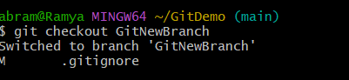

1. **Add some files to it:**



1. **Stage and commit:**

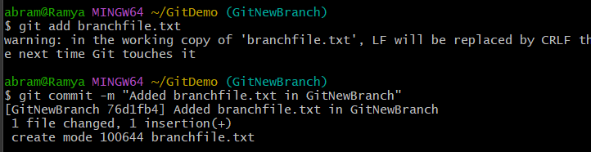

1. **Check status:**

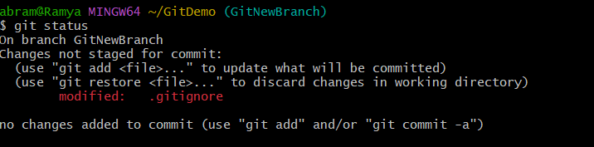

1. **Switch back to master (or main):**

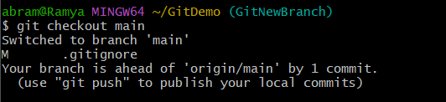

1. **List command-line differences:**

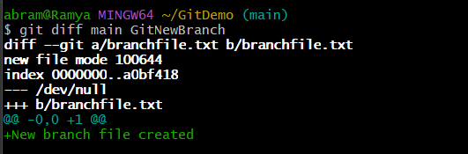

1. **List visual differences using P4Merge:** 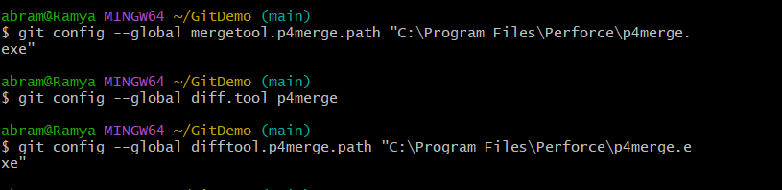

**9.Merge the branch into main:**

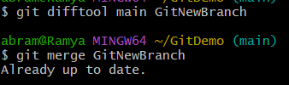

**10.Observe the merge log:**

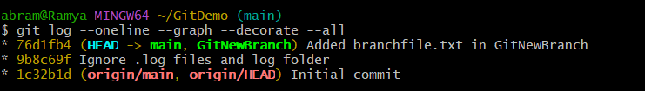

**11.** **Delete the branch after merging:**

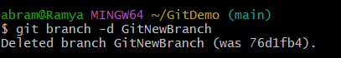

**12.** **Check status:**

